English Language Test One

Grade six

Name: ………………………………. class: ………………………………

**LISTENING 1 (Items 1-5)** **(2.5 marks)**

You are going to hear five short texts. For each text, there is one statement. Is each statement True or False? Listen, and shade in the bubble under the correct option.

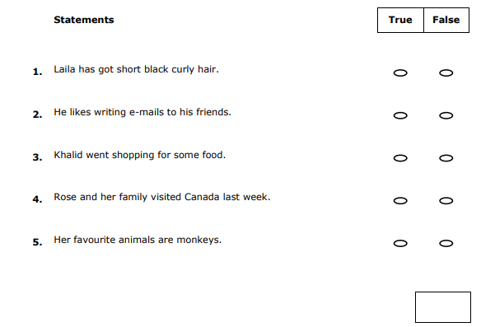

**LISTENING 2 (Items 6-10) (2.5 marks)**

You are going to hear a story about Mohammed and Ali. Listen and for each item, shade in the bubble next to the correct option.

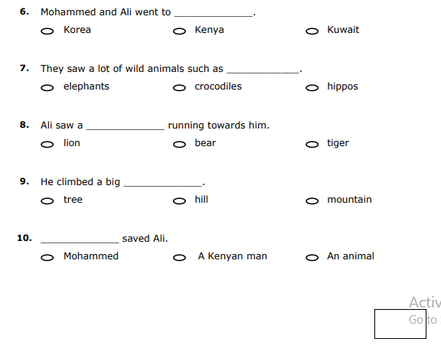

**READING 1 (Items 1-5) (2.5 marks)**

Match the texts with the pictures. For each text, shade in the bubble under the correct option.

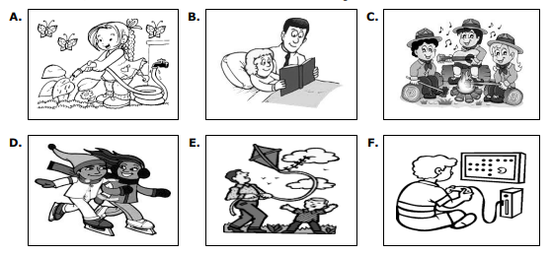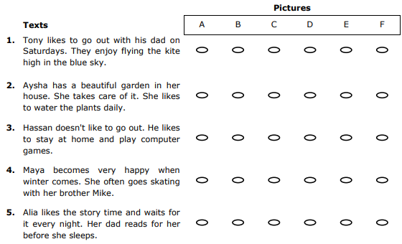

**READING 2 (Items 6-10) (2.5 marks)**

Read the text. For each question, write a short answer (not more than FOUR WORDS).

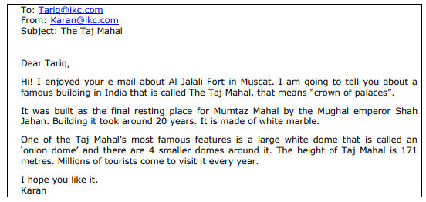

6. Who is the e-mail to?

______________________________________________________

7. What does The Taj Mahal mean?

______________________________________________________

8. What is The Taj Mahal made of?

______________________________________________________

9. How many domes are there in The Taj Mahal?

______________________________________________________

10. Who come to visit it every year?

______________________________________________________

"I'm sure you can do it successfully"

T.Ebtisam Alkasbi

LISTENING 1 (Items 1-5)

1. Laila is a beautiful girl. She's got black eyes and long brown curly hair.

2. Ahmed has lots of friends from different countries. He likes to write e-mails to them in his free time.

3. Yesterday, Khalid's mother asked him to go shopping for some fruit and vegetables. She gave him a long list.

4. Rose and her family are from Canada. Last week, they visited Oman for the first time.

5. Asma goes to the zoo on Fridays. Her favourite animals are monkeys. She likes to feed them lots of bananas.

LISTENING 2 (Items 6-10)

Last year Mohammed and his friend Ali went to Kenya for three weeks. They travelled by plane and stayed in a tent. They saw lots of wild animals and took photographs of them such as elephants, lions and giraffes, but they didn't see any crocodiles. One day, Ali was walking happily taking more photos when he saw a tiger running towards him. He was so scared and started to run, but the tiger ran after him. Suddenly, he saw a big tree and climbed it very quickly. Ali shouted for help. Fortunately a Kenyan man heard him. The man shot the tiger and saved Ali. Mohammed and Ali enjoyed their holiday but they decided to visit another country next year.

